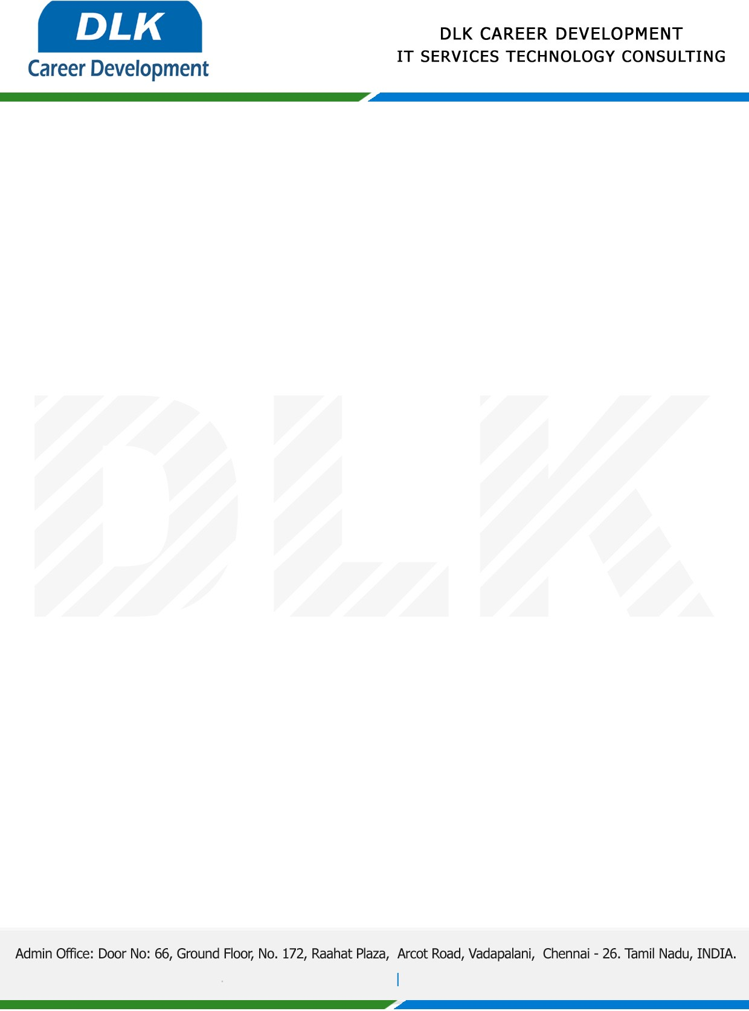

**Date: 27/April/ 2023**

**SUB: PROJECT COMPLETION CERTIFICATE**

This is to certify that **MR ESWARMURTHY B (REG NO:** **RA2152008010022)**

**MBA-Artificial Intelligence and Data Science,** final year student at **SRM University** has Successfully Completed his Project Work under the domain of “**PYTHON”** in our organization during the Period **(1st March 2023 to 20th April 2023)**

**Topic**: Sentimental Analysis Using Stock Market Prediction Using Machine Learning and Deep Learning

We appreciate your interest in **DLK CAREER DEVELOPMENT**

**“Best Wishes for Your Future Endeavors “**

